**Name: Swarali Dandekar**

**Employee ID: 201323**

**Project Topic: Automation of Khadi Naturals Website using Selenium and creating a Docker image**

1. **Selenium Project**

Create a spring project and generate a zip file and extract into the folder.

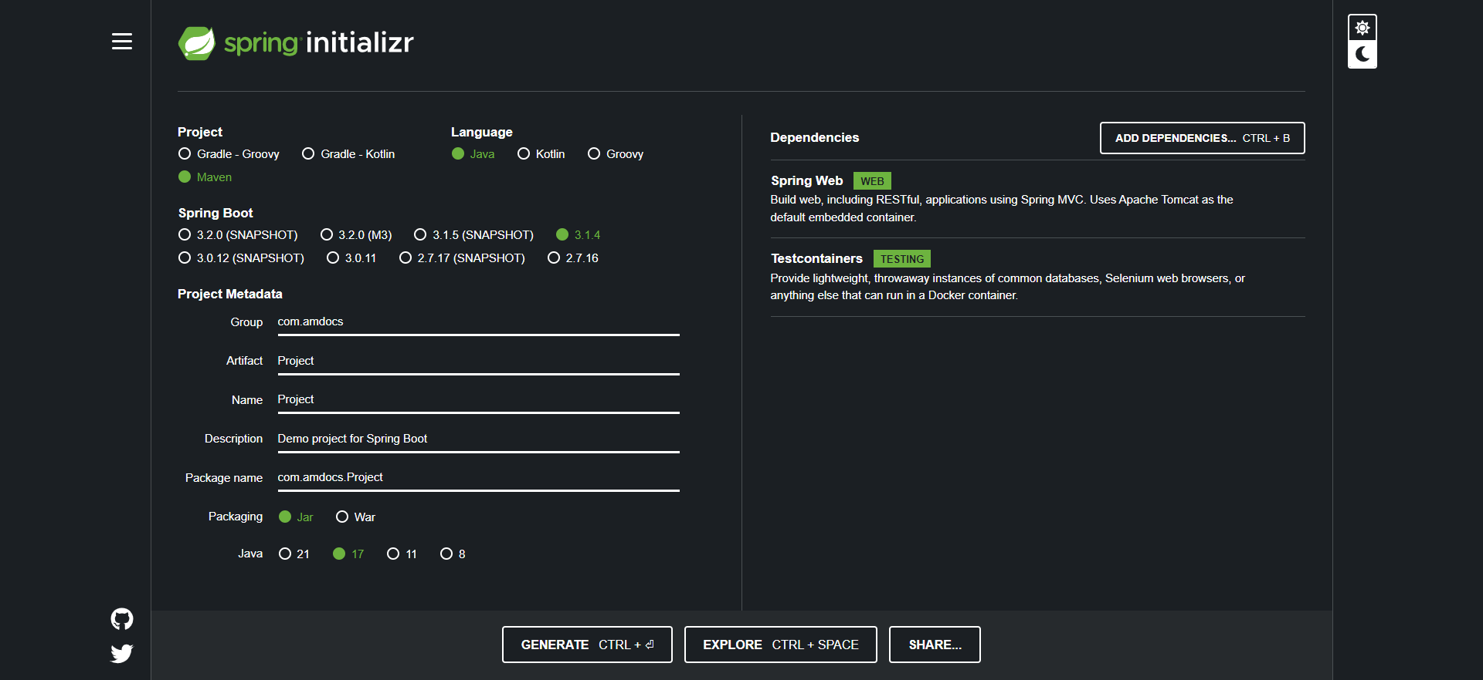

Import the extracted zip file.

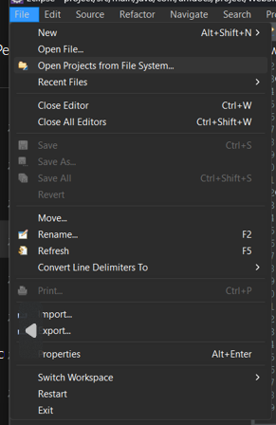

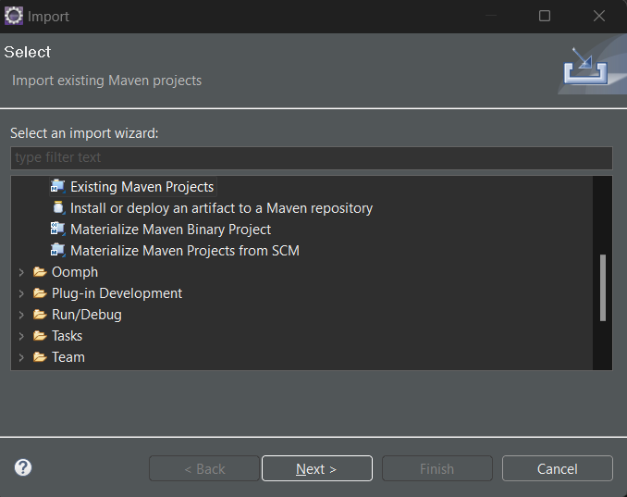

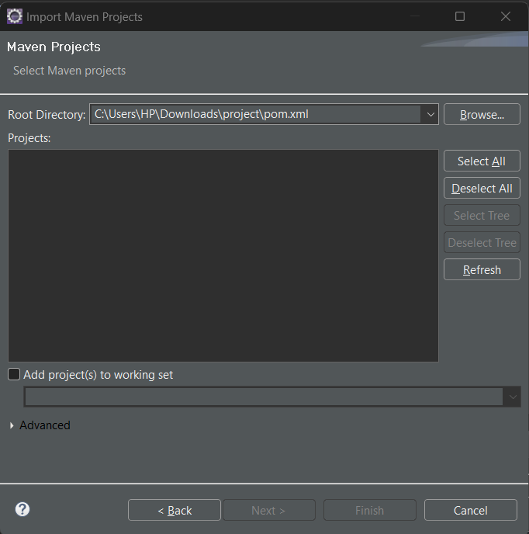

Add dependency in pom.xml:

<!-- https://mvnrepository.com/artifact/org.testng/testng -->

<dependency>

<groupId>org.testng</groupId>

<artifactId>testng</artifactId>

<version>7.8.0</version>

<scope>test</scope>

</dependency>

<!-- https://mvnrepository.com/artifact/org.seleniumhq.selenium/selenium-java -->

<dependency>

<groupId>org.seleniumhq.selenium</groupId>

<artifactId>selenium-java</artifactId>

<version>4.12.0</version>

</dependency>

<!-- https://mvnrepository.com/artifact/io.github.bonigarcia/webdrivermanager -->

<dependency>

<groupId>io.github.bonigarcia</groupId>

<artifactId>webdrivermanager</artifactId>

<version>5.5.3</version>

</dependency>

Code:

*dr*=new EdgeDriver();

//load the website

*dr*.get("https://www.khadinatural.com/");

//maximize the window

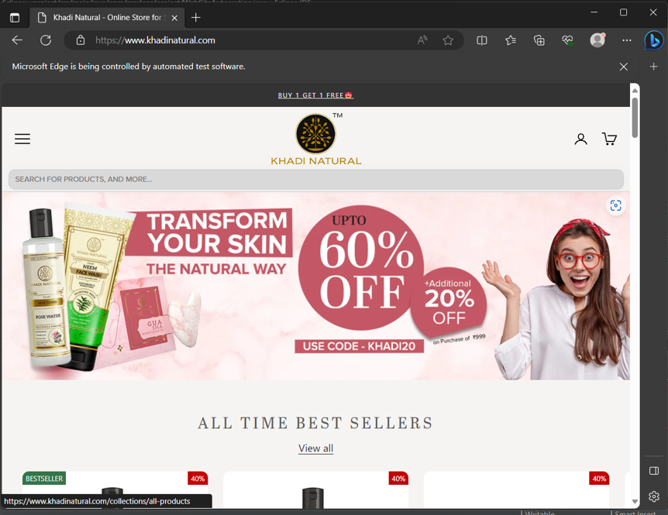

*dr*.manage().window().maximize();

//Thread.sleep()-refers to the wait of action for the specified time

Thread.*sleep*(4000);

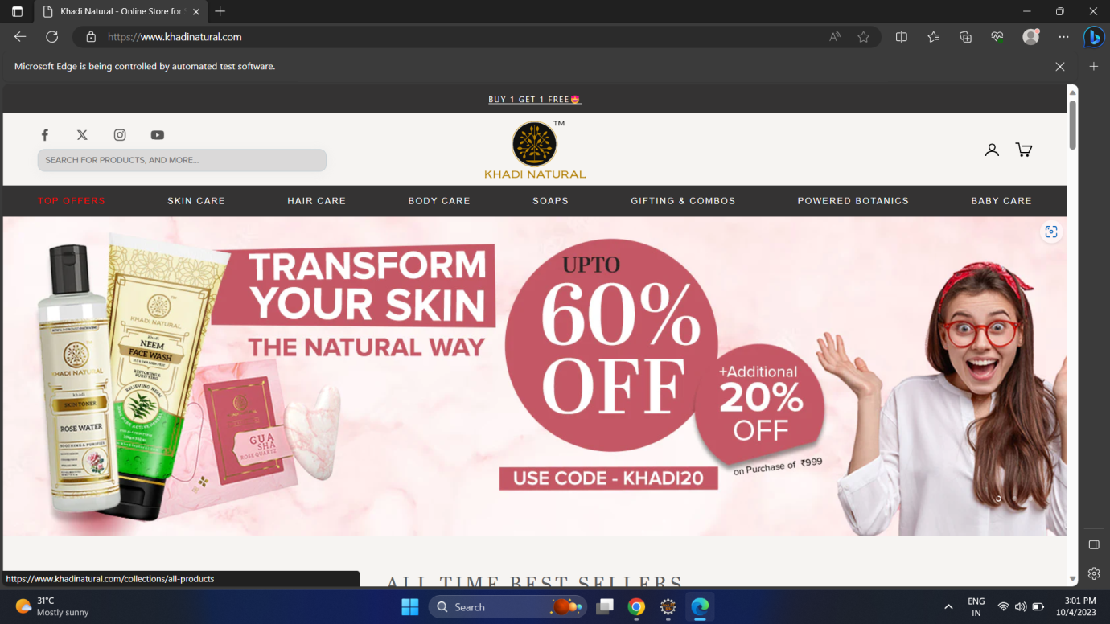

//login into the account

WebElement login=*dr*.findElement(By.*xpath*("//*[@id=\"shopify-section-sections--20758378807618__header\"]/height-observer/x-header/nav[2]/a[1]"));

login.click();

Thread.*sleep*(5000);

WebElement mail=*dr*.findElement(By.*xpath*("//*[@id=\"input-template--20758378119490__main--customeremail\"]"));

mail.sendKeys("dandekarswarali0721@gmail.com");

WebElement pass=*dr*.findElement(By.*xpath*("//*[@id=\"input-template--20758378119490__main--customerpassword\"]"));

pass.sendKeys("Khadinatural@07");

*dr*.findElement(By.*xpath*("//*[@id=\"customer_login\"]/button")).click();

Thread.*sleep*(3000);

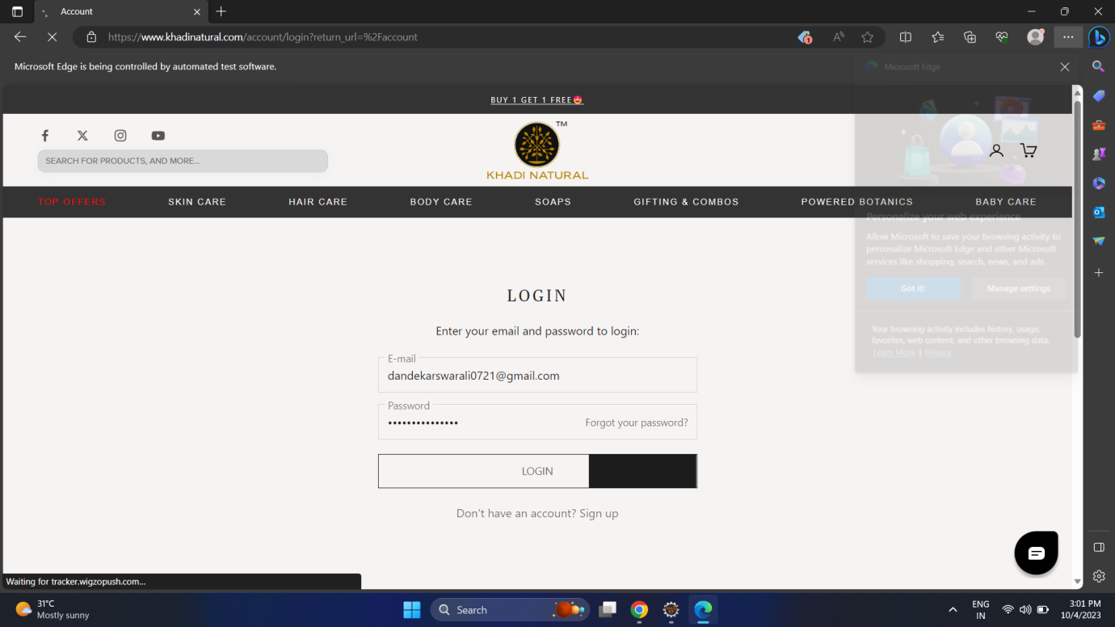

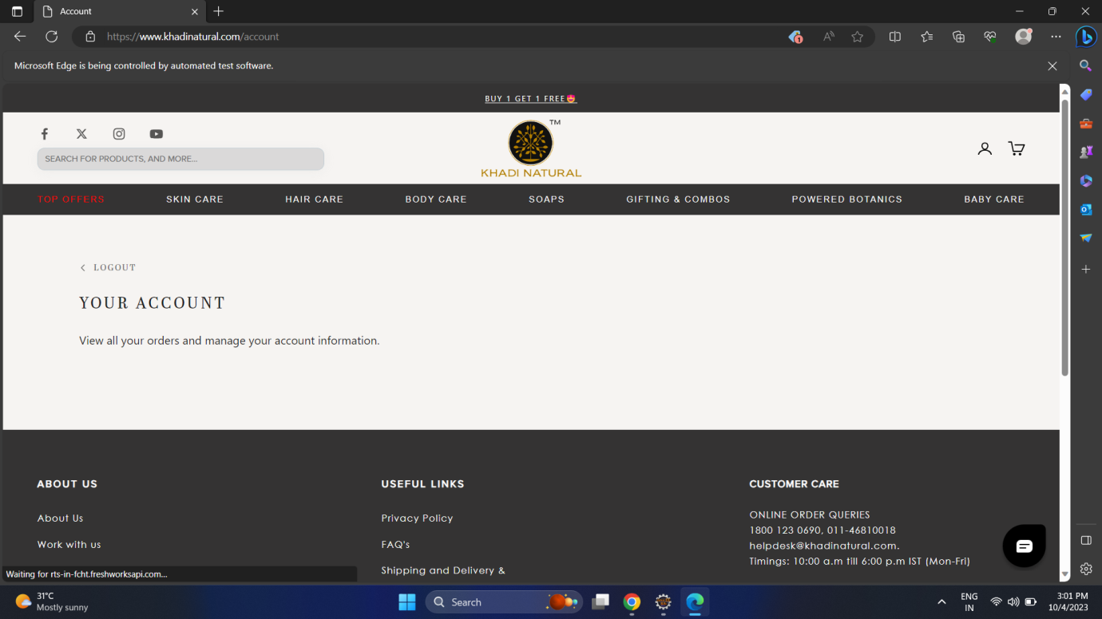

//navigation to skincare and adding product to cart

*dr*.navigate().to("https://www.khadinatural.com/collections/skin-care");

*dr*.findElement(By.*xpath*("//*[@id=\"shopify-section-template--20758376841538__main\"]/div/div/height-observer/div/div[1]/button")).click();

*dr*.findElement(By.*xpath*("//*[@id=\"product_form_6722639953971\"]/button")).click();

Thread.*sleep*(3000);

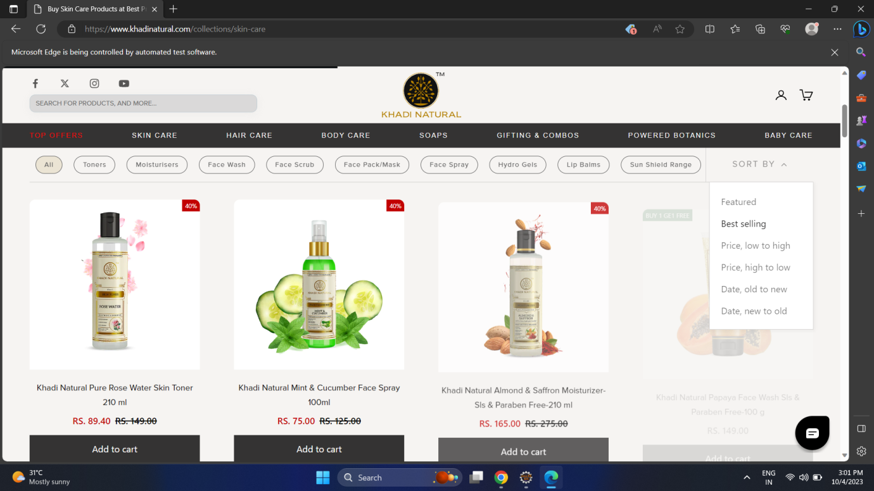

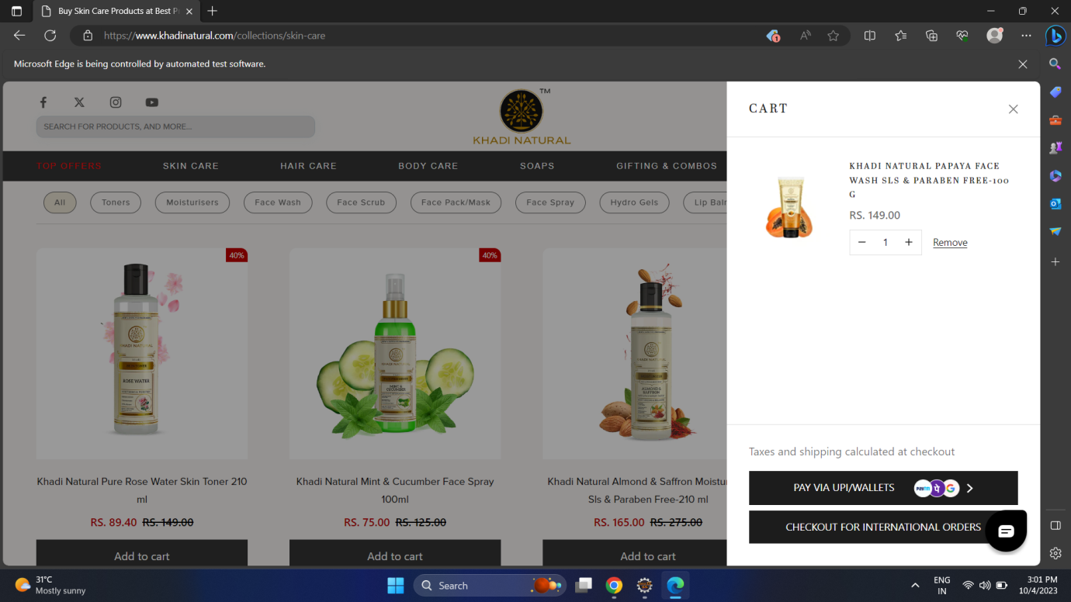

//navigating to gifts/combos and adding product to cart

*dr*.navigate().to("https://www.khadinatural.com/collections/gifts-kits-combos");

*dr*.findElement(By.*cssSelector*("#product_form_6722591260723 > button")).click();

Thread.*sleep*(3000);

*dr*.findElement(By.*xpath*("//*[@id=\"cart-drawer\"]/form/div[2]/button[2]")).click();

Thread.*sleep*(3000);

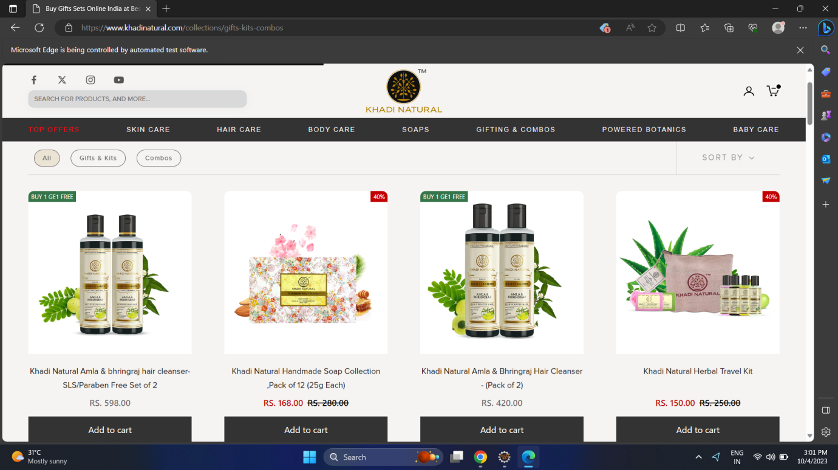

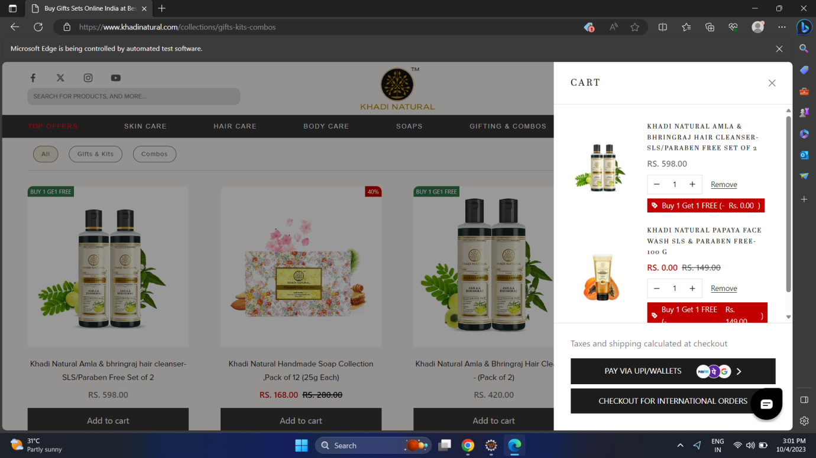

//procedure to add address for shipping-(once added it gets saved no need to add again)

// dr.findElement(By.xpath("//*[@id=\"shipping-address1\"]")).sendKeys("Panvel");

// dr.findElement(By.xpath("//*[@id=\"TextField3\"]")).sendKeys("Navi Mumbai");

// Select s=new Select(dr.findElement(By.xpath("//*[@id=\"Select1\"]")));

// s.selectByVisibleText("Maharashtra");

// dr.findElement(By.xpath("//*[@id=\"TextField4\"]")).sendKeys("410206");

// dr.findElement(By.xpath("//*[@id=\"TextField5\"]")).sendKeys("9845123652");

//dr.findElement(By.xpath("//*[@id=\"pay-button-container\"]/div/div/button")).click();

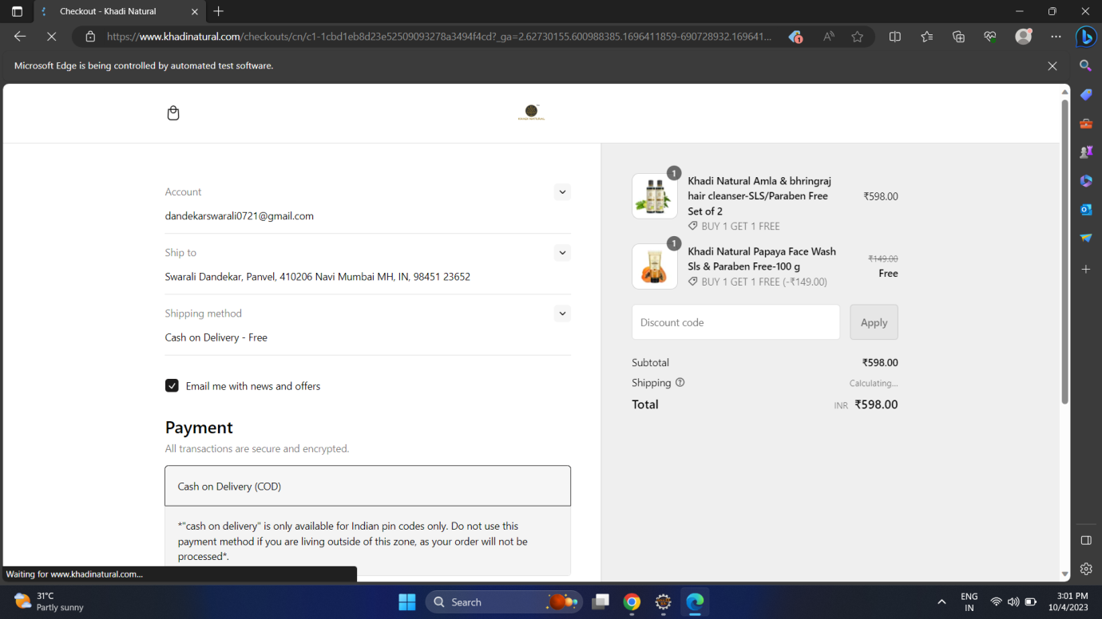

**Code for testing:**

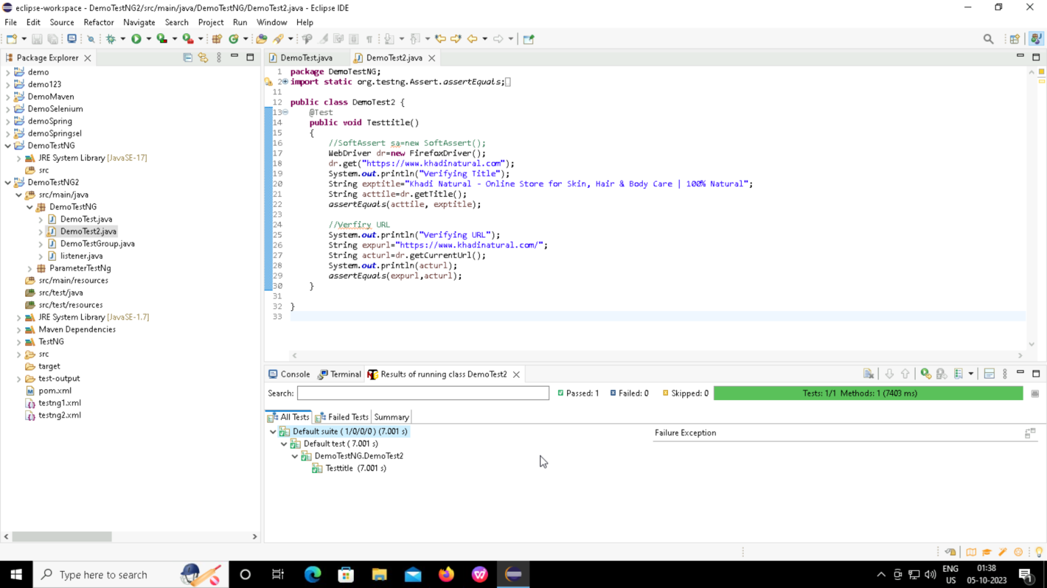

1. **Docker Project:**

Create a simple spring boot project ; run it and create a docker conatainer and image of the same.

package com.example.demo;

import org.springframework.web.bind.annotation.GetMapping;

import org.springframework.web.bind.annotation.RestController;

*@RestController*

public class DockerProject {

*@GetMapping*("/get")

public String show1()

{

return "Docker-Docker is an open platform for developing, shipping, and running applications.";

}

*@GetMapping*("/in")

public String show2()

{

return "This is a Docker Project which show how to dockerize a simple spring boot project.";

}

}

FROM openjdk:17

EXPOSE 8085

ADD target/jarfile.jar jarfile.jar

ENTRYPOINT ["java","-jar","/jarfile.jar"]

